VOCAB
By Michael J. Goodwin

Welcome to the VOCAB program. It is an ideal tool to help learn terms and definitions. It can be used in the fields of foreign language, medicine, horticulture, herbology, any discipline where you need to learn the “language.”

A unique feature of this program is that it allows the user to create topic files using a text format file created by any word processor or text editor. The program will import this file every time it is opened so any changes or additions are instantly usable. The scope is limitless.
Every time the program is run, the matching words are randomized so the order is always different.

Files Provided: Do not delete or rename any of these files.
vocab.exe - executable program
vocab.txt - master word file
msvcr70.dll
vfp7r.dll
vfp7renu.dll

Note: There are many working and index files created by running this program. They may be deleted if you wish.

Procedure:
Update vocab.txt with your vocabulary word list. See Data File Information section below for details.
Execute vocab.exe

Instructions:
The two options available are the 1 up word definition module and the 20 Word Matching Exercise Module.

The 1 up word definition module allows you to answer if you knew the definition. If not, you will have the chance to rerun the words you missed as a separate collection of words. You must go through the entire list for the rerun option to work.

The 20 Word Matching Exercise Module.
It displays up to 20 words in a list and prompts for corresponding matching definitions, sorted in a random order. When you finish the screen, all incorrect matches are displayed for your review. If there are more than 20 words in your original file, you are prompted to continue. If you say “Y” for yes, the next grouping of 20 words would be displayed, etc. until the file list is exhausted. Example, if you have 110 words in your file, you would have 5 screens of 20 and 1 screen of 10.

DATA FILE INFORMATION
The data file used for this program is vocab.txt files. It is imported fresh every time the program is executed so all changes are included in the new run.

The limit in width for the word and matching definition columns is 40 characters each and a category selection field, the third position, which must contain a number from 1 to 3.

These files can be edited but must follow the format of first word, colon delimiter, second word, colon delimiter, and a category number: as follows,
Animal:wanyama:1

I have used the category number of 1 to display English first than the description second.
I use 2 to reverse the flow and put the description first and the English second.
Category 3 combines category 1 and 2 together and displays them in a random order.
This can be easily done in text editor by copy and paste and replacing the 1 with a 2 or 3. Or by running the convert option, item 4 on the Vocab Program Screenl

If you edit the “converted” file, you will see a different format created by the program.
You will see “one”:”uno”:”1”.
Disregard the double quote marks as the computer will use them if there and ignore the fact that they are not present.

Legal:
I welcome any comments and suggestions for future versions.

I hope you are able to benefit from the use of this program. Please email any comments to me at miklgoodwin@gmail.com with vocab in the subject line. I will let you know when future versions are available.

3/26/2023

Release Notes:
3/26/23
English text files contained in the text files (ie, Lesson1.txt and Lesson2.txt) will need to be edited to include any foreign language translation, if desired. If not edited, the second word will be the same as the first word. (The 24 lessons for English Connect 1 and 2 are combined in text format.)
Example lesson1-3.txt shows: January::1:3.
If desired, the foreign language word would be inserted between the two colons (::) to be like this:
January:enero:1:3
If not edited, the word match module will create the record “January:January:1:3”
The number 3, after the 1, is insignificant in the processing and only represents the lesson number for that segment.
The 20 word matching module output will look as below:
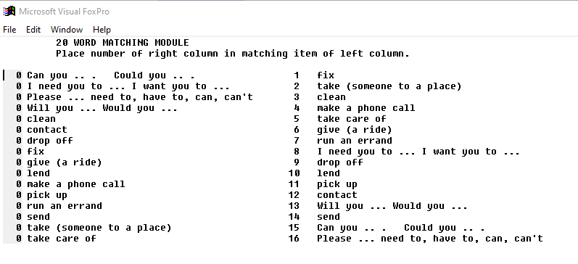

------------------------------------------------------------------------------------------------------
Screen Print Documentation

Screen #1
Main Program Screen. Only 1 choice is available.

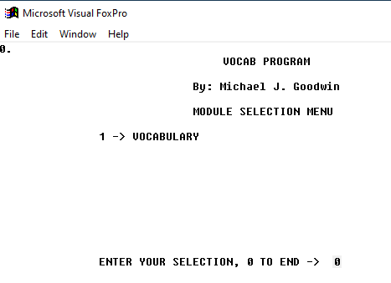

Select option 1 on this screen or 0 to end.

Screen #2

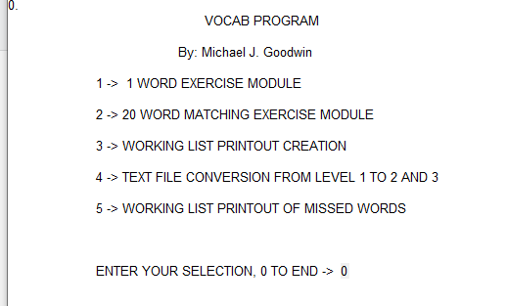

Selection 1 gives you the one up word matching option.
Selection 2 gives you the 20 word side by side option.
Selection 3 provides an exported text file which can be edited in a word processor and/or printed out to use as a worksheet. The filename is temp.txt which can/should be named to an appropriate name for later use. This file will be overwritten each time option 3 is executed.
Selection 4 will process the text file you indicate by creating a duplicate of category 1 words reversing the positions of the first and second words and adding a category indicator of 2. Both 1 and 2 words will be combined and adding a category indicator of 3. This increases the challenge of the program.
All final options of the modules brings you back to this screen. Enter 0 to end the program.
Selection 5 provides an exported text file of only recently missed words, which can be edited in a word processor and/or printed out to use as a worksheet. The filename is temp1.txt which can/should be named to an appropriate name for later use. This file will be overwritten each time option 3 is executed.

Screen #3
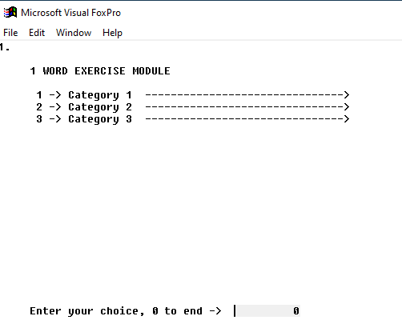

Selecting option 1 brings up this screen.

One up word matching screen.

Select options 1, 2, 3 or 0 here.

Option 1 gives you the first word of the .txt file to identify in the one up option or puts the first word in
the left column of the 20 word format.
The way these txt files are setup, the first word is in English and the matching word in working language.
In the sample txt files given, there is a 1 in the 3rd position of the txt file, the category position.

Option 2 gives you the reverse of option 1 meaning working language words first and English second.
In the sample txt files given, there is a 2 in the 3rd positon of the txt file.

Option 3 gives you an assortment of both in the first and second columns.
In the sample txt files given, there is a 3 in the 3rd positon of the txt file.

Screen #4

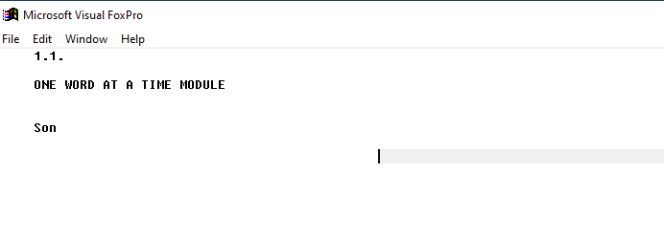

Option 1 of screen #3 brings you to this screen.
One word option using category 1 words.

On this screen, you can type the response for the word displayed or simply press the Enter key.
No comparison will be done between what you type and the actual answer.

Screen #5

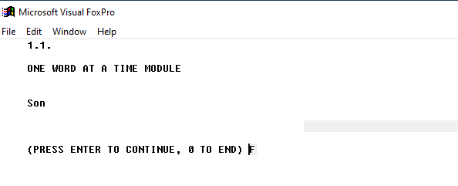

Press the Enter key to continue with the next word in the list.
Continue to the end and you will be able to redo the words missed.
If you enter a 0 here, the missed word list will be discarded.

Screen #6
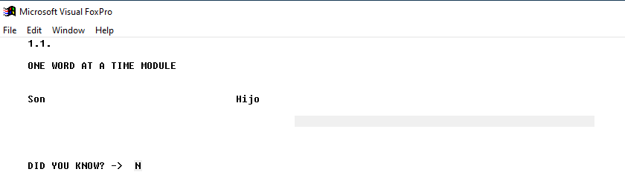

This screen asks you to verity whether you knew the word or not.
I you did know it, enter a Y here, otherwise press the Enter key for No.

Screen #7
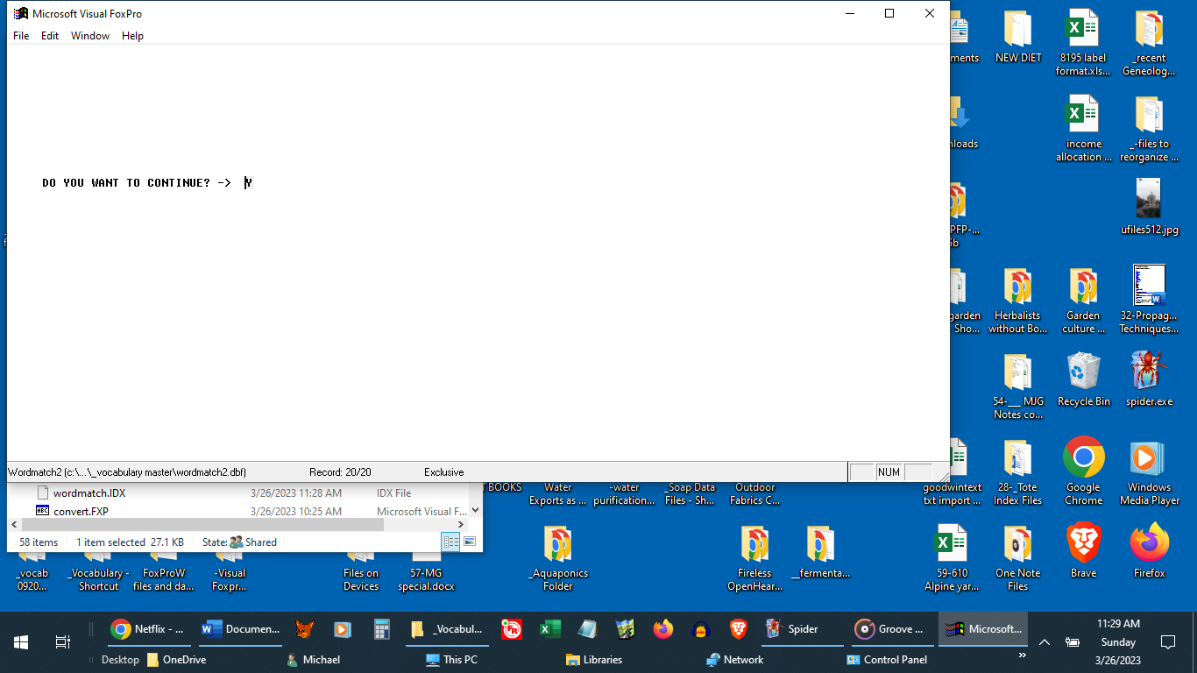

Press the Enter key to continue to the next word.

Screen #8
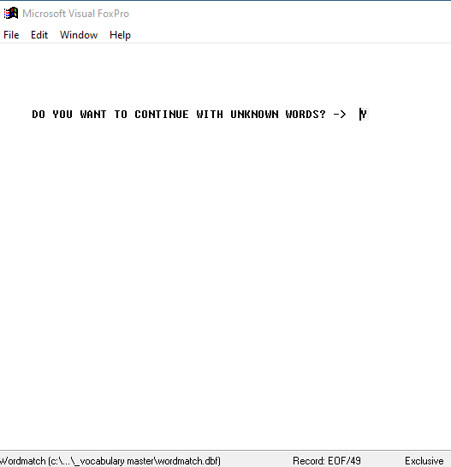
This screen allows you to reprocess the unknown words list.

Screen #9
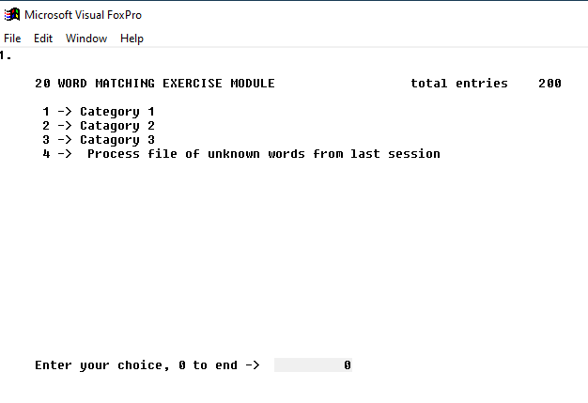

This is the 20 word Matching Exercise Module

Option 1 puts the first word in the left column of the 20 word format. See screen #3 description above for other options.
Words are displayed 20 at a time. Fill in the blank with the number of the word in the right column which matches.

Screen #10
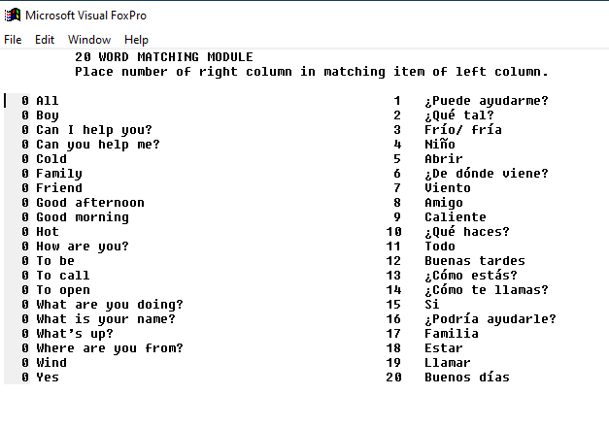

When you get to the end of the 20 word column, pressing enter on the 20th word brings up the following screen.

Screen #11
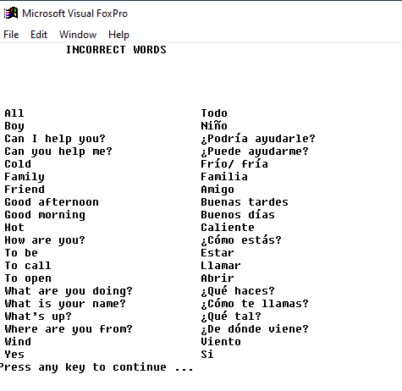

This screen show all the missed words.

Screen #12

Answering Yes to this prompt brings up the next 20 words in the word list, and will continue to do this until the list is exhausted as displayed in the next screen.

Screen #13
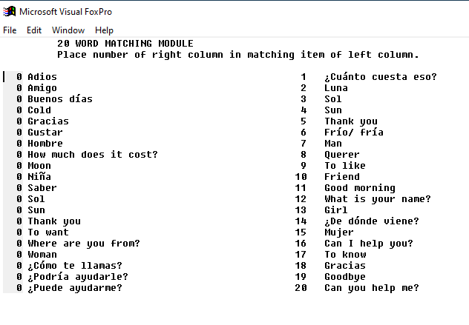
Second screen of words to match.

